**Demo #2**

**Team:** Codework Digital

**URL:** **thetalkmadesimple.com**

**Team Members:** Cat Schnelle, Chanse Stephens, Kevin Sims, Elijah Pemberton

**Group #:** 4

**Course:** CSCI-441-VA-Software Engineering

**Github:**[**https://github.com/CSchnelle/Codework-Digital**](https://github.com/CSchnelle/Codework-Digital)

**Individual Contributions Breakdown**

**Demo #2**

Chanse Stephens

* **Programming:**
* Changes for landing-page.php
* Changes made for lessons page
* Code for get-started.php
* Backend configuration of plugins
* Code for single post page
* Code for my account page
* Code for contact page
* Code for 404 page
* Code for functions.php
* **Project Management:**
* Organized code
* Video Presentation for Demo
* Manage Repository Files
* Helped others test file changes

Cat Schnelle

* **Programming:**
* Code for get-started.php
* Code for footer.php
* **Project Management:**
* Brochure
* Presentation slides
* Set up /manage repository
* Roadmap / Plan of Work

Elijah Pemberton

Kevin Sims

* **Programming:**
* Configured Google Analytics
* Code for search.php

Project Management

We have received feedback from our client since the first Demo and have made some layout, functionality, and UI changes to the site. We added a “Get Started” page that will have information explaining more about how the subscription service for courses work. The layout is divided into separate sections that first have a call to action button at the top to drive new users to sign up. Directly below that is a section for a site trailer that the client will later upload to introduce new users to the course experience, followed by an information section container that the client can post to. A bootstrap stepper was implemented as a secondary call to action to demonstrate the simplicity of signing up for the service and finally a Frequently asked questions section using Bootstrap linked drop down menus. Additionally the site will no longer be structured to pay by each course with additional free content but rather, a subscription service unlocking the entire service and no free content will be hosted. This change did not alter the underlying structure or system as the site was designed, rather a setting was changed within WordPress itself that changes what the user is paying for, unlocking all the material at once upon payment, instead of unlocking each course one by one. Once that change was made a Lessons page was added. This page has a UI implemented that divides the page into separate containers. The top portion shows available courses with information and the lower section of the page separates them further into categories to explore. The account page for account set up and login has been implemented only capturing email and password as the client requested. Reports and site tracking have been fully implemented that will not only track traffic but sales as well on the same report. Going forward we are meeting with the client to discuss any additional changes that need to be made and we are finishing the user manual for the client so that they may upload their personalized content with ease. Our goal is to ease the client into the process of hosting their content while we continue to provide support and instruction, making any additional tweaks as needed.

Roadmap

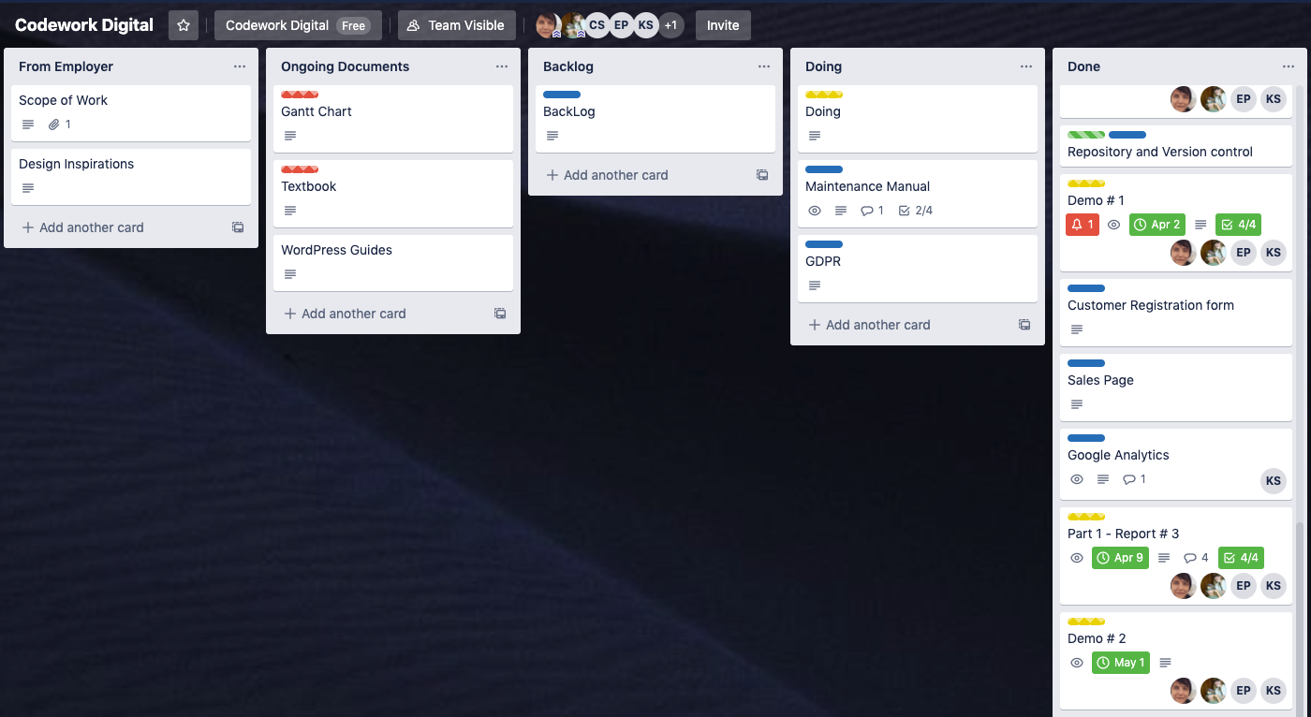

Plan of Work

